41.41: Decay from a 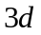 to 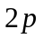state in hydrogen means that 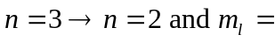 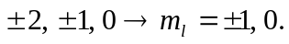 However selection rules limit the possibilities for decay. The emitted photon carries off one unit of angular momentum so must change by 1 and hence 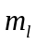 must change by 0 or 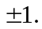 The shift in the transition energy from the zero field value is just
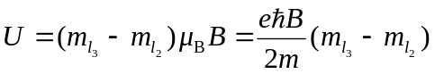
where 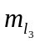is the 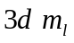 value and 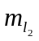is the 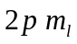 value. Thus there are only three different energy shifts. They and the transitions that have them, labeled by 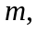 are:
